Assignment 2 – Operating Systems

NAME: S KIRISH
REG.NO: 1972260065
COURSE NAME: OPERATING SYSTEM COURSECODE: CSA0407
GITHUB LINK : https://github.com/kirishh06/CSA0407-Operating-system-

Q1 – Processes and Process States (6 Marks)
- Process-State Diagram

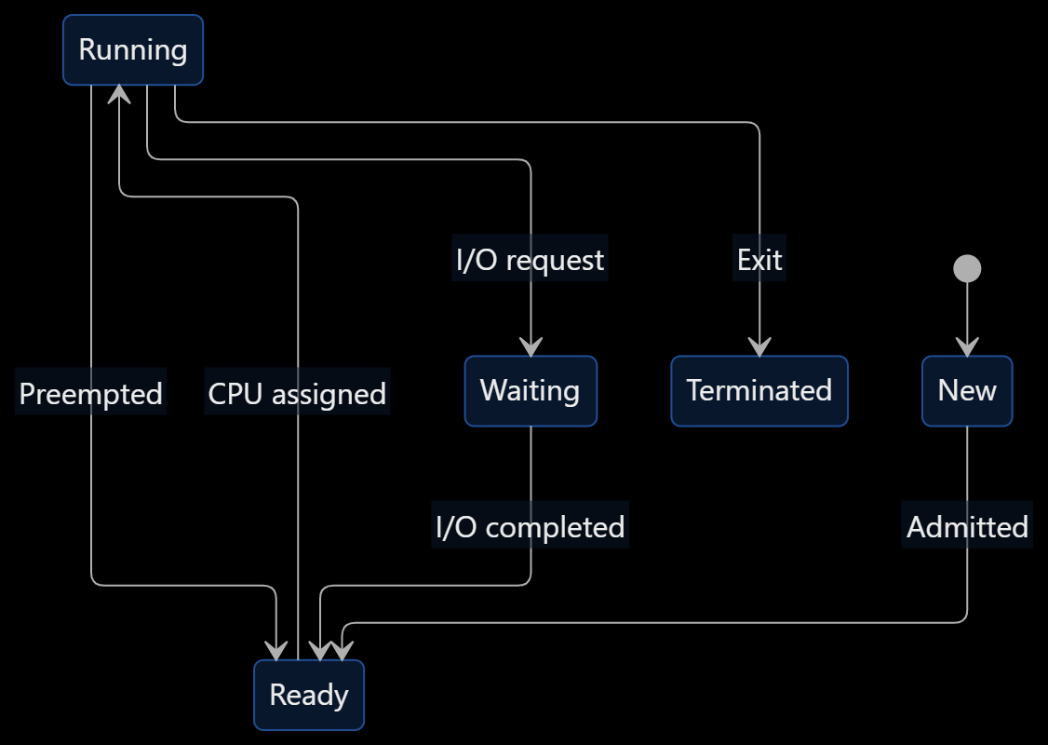

Process States

State | Description
New | Process is being created
Ready | Process waits for CPU
Running | Process executes on CPU
Waiting | Process waits for I/O or an event
Terminated | Process has completed
- Process Control Block (PCB)
A PCB stores the information required to manage a process.
  - Process ID (PID)
  - Process state
  - Program counter
  - CPU registers
  - Scheduling information
  - Memory management information
  - I/O status
  - Accounting information
- C Program Using fork()
C
#include <stdio.h> #include <unistd.h>

#include <sys/wait.h> int main()
{
for (int i = 0; i < 3; i++)
{
pid_t pid = fork(); if (pid == 0)
{
printf("Child PID: %d\n", getpid());
_exit(0);
}
}
while (wait(NULL) > 0); printf("Parent completed\n"); return 0;
}
Compile and execute:
Bash
gcc process.c -o process
./process ps -ef

Evaluation
When 2,000 student processes run simultaneously:
  - Context switching increases.
  - Memory consumption increases.

  - CPU time is spent managing processes.
  - I/O waiting may reduce CPU utilization.
  - The server may become overloaded.

Design Decision
A fixed pool of worker processes is recommended.

Design | Advantages | Disadvantages
Process per student | Strong isolation | High memory and creation cost
Thread per student | Lower memory usage | Shared-memory safety issues
Worker pool | Controlled resource usage | Requires queue management

Conclusion: A worker pool provides a good balance between performance, memory usage and reliability.

Q2 – CPU Scheduling (8 Marks)

Scheduling Algorithms

Algorithm | Description | Advantage | Disadvantage
FCFS | First process arriving executes first | Simple | Convoy effect
SJF | Shortest job executes first | Low average waiting time | Long-job starvation
SRTF | Shortest remaining time executes | Good response for short jobs | More context switches
Priority | Highest-priority process executes | Important jobs get CPU | Low-priority starvation
Round Robin | Each process receives a time quantum | Fair CPU allocation | Quantum affects overhead

Scheduling Formulas

𝑇𝐴𝑇 = 𝐶𝑇 − 𝐴𝑇

𝑊𝑇 = 𝑇𝐴𝑇 − 𝐵𝑇

𝑅𝑇 = 𝑆𝑇 − 𝐴𝑇

Where:
  - CT = Completion Time
  - AT = Arrival Time
  - BT = Burst Time
  - ST = First Start Time
  - TAT = Turnaround Time
  - WT = Waiting Time
  - RT = Response Time

Round Robin Program
The assignment provides:

Process | Arrival Time | Burst Time
P1 | 0 | 8
P2 | 1 | 4
P3 | 2 | 9
P4 | 3 | 5
Time quantum = 3. C
#include <stdio.h> #define N 4
int main()
{
const char *name[N] = {"P1","P2","P3","P4"};

int arrival[N] = {0,1,2,3};
int burst[N] = {8,4,9,5}; int quantum = 3;
int left[N], finish[N], queue[64]; int head=0, tail=0, added[N]={0}; for(int i=0;i<N;i++)
left[i]=burst[i]; int time=0, done=0; queue[tail++]=0; added[0]=1; printf("Gantt:"); while(done<N)
{
int p=queue[head++];
int run=(left[p]<quantum)?left[p]:quantum; int start=time;
time+=run; left[p]-=run;
printf(" %s(%d-%d)",name[p],start,time); for(int i=0;i<N;i++)
{
if(!added[i] && arrival[i]<=time)
{
queue[tail++]=i;

added[i]=1;
}
}
if(left[p]>0) queue[tail++]=p;
else
{
finish[p]=time; done++;
}
}
double tw=0,tt=0; printf("\nProcess TAT WT\n"); for(int i=0;i<N;i++)
{
int tat=finish[i]-arrival[i]; int wt=tat-burst[i]; tt+=tat;
tw+=wt;
printf("%s %d %d\n",name[i],tat,wt);
}
printf("Average TAT = %.2f\n",tt/N); printf("Average WT = %.2f\n",tw/N); return 0;

}

Expected Output
Plain text
Gantt: P1(0-3) P2(3-6) P3(6-9) P4(9-12)
P1(12-15) P2(15-16) P3(16-19) P4(19-21) P1(21-23) P3(23-26)
Process TAT WT P1 23 15
P2 15 11
P3 24 15
P4 18 13
Average TAT = 20.00 Average WT = 13.50

Effect of Time Quantum

Quantum | Context Switches | Waiting Time | Evaluation
1 | Very high | Generally lower response delay | High overhead
3 | Moderate | 13.50 | Balanced
5 | Lower | Depends on execution order | Less overhead
20 | Very low | Similar to FCFS | Poor responsiveness

Alternative Concept: Multilevel Feedback Queue
A multilevel feedback queue uses multiple queues with different time quanta.
  - New jobs enter the highest-priority queue.
  - Short jobs finish quickly.
  - Long jobs move to lower-priority queues.
  - Waiting jobs receive priority through aging.

Complexity:
  - Round Robin with a queue: approximately 𝑂(1)queue operations per scheduling decision.
  - SJF using a simple search: 𝑂(𝑛)per decision.
  - Starvation: possible in SJF and priority scheduling.
  - Aging: reduces starvation by increasing waiting processes' priorities.
Conclusion: Round Robin is recommended for the video service because it provides fairness and responsive execution for short and long jobs.

Q3 – Threads (6 Marks)

Introduction
A traffic-camera system processes number plates from 64 cameras. Threads allow multiple camera frames to be processed simultaneously.

Resources Shared by Threads

Shared Resources | Private Resources
Code section | Stack
Global variables | Registers
Heap memory | Thread ID
Open files | Thread-specific data

Thread Models

Model | Description
Many-to-One | Many user threads map to one kernel thread
One-to-One | Each user thread maps to one kernel thread
Many-to-Many | Many user threads map to multiple kernel threads
Recommended: One-to-one threading using POSIX threads because it allows true parallel execution on multiple CPU cores.

C Program Using POSIX Threads
C
#include <stdio.h> #include <pthread.h> #define N 64
void *process_camera(void *arg)
{
int id = *(int *)arg;
printf("Camera %d processed\n", id); return NULL;
}
int main()
{
pthread_t threads[N]; int id[N];
for(int i=0;i<N;i++)
{
id[i]=i+1; pthread_create(&threads[i],NULL,
process_camera,&id[i]);
}
for(int i=0;i<N;i++) pthread_join(threads[i],NULL);
return 0;

}
Compile:
Bash
gcc camera.c -o camera -pthread
./camera

Thread Pool Comparison

Pool Size | Expected Performance
4 threads | Lower resource usage
8 threads | Better parallelism
16 threads | Higher parallelism, more overhead
64 threads | High overhead and scheduling cost

Speed-up:

𝑆 = 𝑇1
𝑇𝑛

Efficiency:

𝑆
𝐸 = 𝑛

Speed-up stops increasing because of:
- Limited CPU cores.
- Memory bandwidth.
- Lock contention.

- Thread scheduling overhead.

Shared Counter Problem
If two threads update a shared counter without protection, a race condition occurs.
Example:
C
counter++;
This operation includes reading, incrementing and writing. Two threads may overwrite each other's updates.
Conclusion: A fixed thread pool with mutex protection is recommended for traffic-camera processing.

Q4 – Inter-Process Communication (6 Marks)
- Introduction
A weather station contains a sensor-reading process and an analysis process. They must exchange readings continuously without losing data.

Pipe-Based Communication
C
#define _POSIX_C_SOURCE 200809L #include <stdio.h>
#include <unistd.h> #include <sys/wait.h> int main()
{
int fd[2];
pipe(fd);
pid_t pid=fork(); if(pid==0)
{
close(fd[1]);
int value,count=0,sum=0,max=0; while(read(fd[0],&value,sizeof(value))>0)
{
count++; sum+=value;

if(value>max) max=value;
}
printf("analyser: %d readings, average %.1f, max %d\n", count,count?(double)sum/count:0,max);
close(fd[0]);
_exit(0);
}
close(fd[0]);
int readings[]={31,33,36,34,41,38}; for(int i=0;i<6;i++)
write(fd[1],&readings[i],sizeof(readings[i]));
close(fd[1]); waitpid(pid,NULL,0); printf("reader: done\n"); return 0;
}

Expected Output
Plain text
analyser: 6 readings, average 35.5, max 41 reader: done

Pipe vs Shared Memory vs Message Queue

Method | Data Copying | Synchronization | Advantage
Pipe | Kernel copies data | Built-in blocking | Simple
Shared memory | No repeated kernel copying | Requires semaphore/mutex | Fast
Message queue | Kernel copies messages | Built-in queue management | Structured messages

End-of-Data Signal
When the writer closes the pipe's write end, the reader receives EOF after all buffered data is consumed.
If the parent does not close fd[1], the child never receives EOF because the pipe still has an open writer.

Complexity Analysis
For 𝑛readings:
  - Pipe: 𝑂(𝑛)transfer time.
  - Shared memory: 𝑂(𝑛)data access time.
  - Shared memory has lower copying overhead.
  - Pipe is simpler and safer for small data streams.
Conclusion: Pipes are recommended for small continuous sensor readings, while shared memory is preferable for large high-speed data transfers.

Q5 – Synchronization: Critical Sections, Semaphores and Monitors (11 Marks)
- Critical-Section Problem
A critical section is the part of a program that accesses shared resources.
A correct solution must satisfy:
  - Mutual Exclusion: Only one process enters the critical section at a time.
  - Progress: If the critical section is free, a waiting process should be allowed to enter.
  - Bounded Waiting: No process should wait indefinitely.

Peterson's Solution
Peterson's algorithm works for two processes using:
- flag[2]
- turn
It provides mutual exclusion, progress and bounded waiting under the required memory-order assumptions.
However, modern processors may reorder memory operations. Therefore, ordinary variables without atomic operations and memory barriers may not provide correct synchronization.

Binary Semaphore
A binary semaphore has values 0 and 1. C
sem_wait(&mutex);
/* Critical section */ sem_post(&mutex);

It protects a shared seat counter from concurrent updates.

Counting Semaphore
A counting semaphore controls access to multiple identical resources. For example, if 10 seats are available:
C
sem_init(&available,0,10);
Each booking decreases the count, and each cancellation increases it.

Bounded Buffer Problem
The producer-consumer problem uses:
- mutex: protects the buffer.
- empty: counts empty slots.
- full: counts filled slots.
C
sem_wait(&empty); sem_wait(&mutex);
/* Insert item */ sem_post(&mutex); sem_post(&full); Consumer:
C
sem_wait(&full); sem_wait(&mutex);
/* Remove item */ sem_post(&mutex);

sem_post(&empty);

Readers-Writers Problem
Multiple readers may read simultaneously, but writers require exclusive access.
C
sem_wait(&rw_mutex);
/* Writer updates shared data */ sem_post(&rw_mutex);
A reader counter and mutex can allow multiple readers to access data
together.

Dining Philosophers Problem
Five philosophers share five forks.
A deadlock can occur when every philosopher holds one fork and waits for another.
Solutions include:
- Allow only four philosophers to compete at once.
- Acquire forks in a fixed order.
- Use a monitor to control fork allocation.

Monitor
A monitor combines shared data and synchronization operations. Condition variables provide:
- wait(): releases the lock and waits.
- signal(): wakes a waiting thread.
Monitors are easier to maintain because synchronization is contained within one structure.

Railway Ticket Booking Design

Lock Design | Advantage | Disadvantage
Global lock | Simple and safe | Low throughput
Per-train lock | Better concurrency | Some contention
Per-coach lock | Highest concurrency | More complex
Recommended: Per-train locks provide a balance between throughput and implementation complexity.

Q6 – Day-6 Design Challenge: Deadlock Handling and Banker's Algorithm (15 Marks)
- Resource-Allocation Graph (3 Marks)
A resource-allocation graph represents processes and resources.
  - Process: Circle
  - Resource: Rectangle
  - Request edge: Process → Resource
  - Assignment edge: Resource → Process

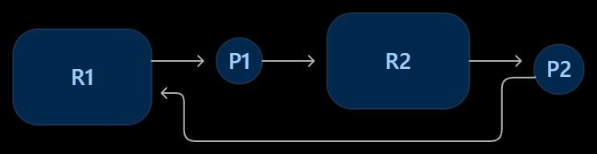

A cycle indicates a possible deadlock. If each resource has only one instance, a cycle indicates deadlock.

Compare Deadlock Strategies (3 Marks)

Strategy | Description | Advantage | Disadvantage
Prevention | Eliminates one necessary condition | Guarantees no deadlock | Restricts resource usage

Avoidance | Grants requests only if state remains safe | Better resource utilization | Requires maximum-demand information
Detection | Allows deadlock and detects it later | Flexible | Recovery cost
Recovery | Terminates or rolls back processes | Removes deadlock | Lost work

Apply Banker's Algorithm (4 Marks)
Banker's algorithm checks whether resource allocation leaves the system in a safe state.

Data Structures
  - Available: currently free resources.
  - Max: maximum resource demand.
  - Allocation: resources currently allocated.
  - Need: remaining resource requirement.
𝑁𝑒𝑒𝑑 = 𝑀𝑎𝑥 − 𝐴𝑙𝑙𝑜𝑐𝑎𝑡𝑖𝑜𝑛

Algorithm
- Set Work = Available.
- Find a process whose Need <= Work.
- Assume it finishes and releases its allocation.
- Add its allocation to Work.

- Repeat until all processes finish.
- If all processes finish, the system is safe.

Predict Before Implementing (1 Mark)
The time complexity of Banker's algorithm increases with the number of processes and resource types.
For 𝑛processes and 𝑚resource types:
𝑂(𝑚𝑛²)

The space complexity is:
𝑂(𝑚𝑛)

Measure (1 Mark)
Run the algorithm for:
  - 10 processes
  - 100 processes
  - 1,000 processes
Record execution time and compare it with the theoretical complexity.

Defend the Final Design (3 Marks)
Recommended: Use Banker's algorithm for controlled resource allocation in non-critical hospital services.
For critical real-time services, prevention and carefully designed resource ordering are preferred because they provide more predictable behavior.

Final Conclusion
The operating system should use:

  - Process pools for high-concurrency workloads.
  - Round Robin scheduling for fairness.
  - POSIX threads for parallel processing.
  - Pipes or shared memory for IPC.
  - Semaphores and monitors for synchronization.
  - Deadlock prevention and Banker's algorithm where resource allocation requires safety.
This combination improves CPU utilization, throughput, reliability and overall system performance.

